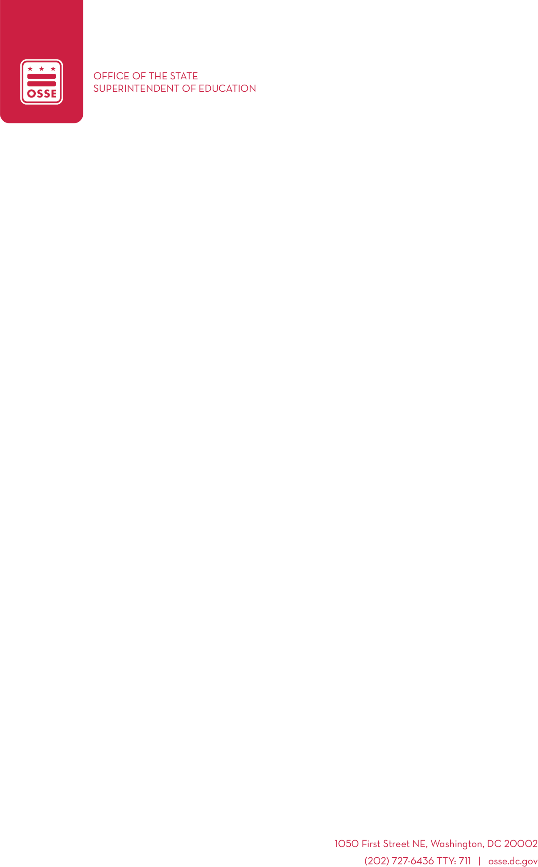

Request Closure for Professional Development Day
Appendix D: Request for Closure to Attend Conference (modified for DC Early EdX) FOR SUBSIDY PROGRAMS ONLY
DC Early Educator Experience (DC Early EdX)
Walter E. Washington Convention Center in Washington, DC April 17, 2026, 9 a.m. - 4 p.m.
Approved Trainer ID: E-174-S24
info@dcearlyedx.org / www.dcearlyedx.org
Complete These Four Steps and Submit Form by March 17, 2026
Step 1. Enter the name of facility here:
Step 2. Register each staff attending DC Early EdX. Each staff person needs their own registration.
Do not use the same email address for each staff person. Register early, this will likely be a sold-out event.
Step 3. Fill out Appendix A and Appendix D
Step 4. Submit the completed forms to your Education Services Monitor by March 17, 2026, for review.

Session Information
Opening keynote by Sonia Manzano, best known for her role as Maria on Sesame Street Closing keynote by Dr. Orinthia Harris, Founder and Executive Director of STEMearly LLC

Overview: Conference keynotes and other learning experiences will reinforce the content of the breakout sessions. Content will be customized to reflect age groups of children and role of the educator.

Attendees will participate in and three breakout sessions, selecting their own sessions throughout the day. The sessions will be uniquely targeted for a variety of early childhood educators, staff, and administrators and customized to reflect, program setting, age groups of children, and role of the educator. Each breakout session block will offer attendees a choice of nine different 60-minute sessions covering various core knowledge areas.
By participating in the 2026 DC Early Educator Experience, attendees can earn up to 7 professional development (PD) hours across six core knowledge areas including Curriculum, Inclusive Practices, Personal Development and Self-Care, Professionalism and Advocacy, and Social-Emotional Development and Mental Health, and Child Growth and Development.
In between the second and third breakout session blocks, lunch will be provided. During this time, participants will have an opportunity to network with other attendees, interact with fellow early childhood educators, and learn about resources available from the four host organizations.
Appendix A
Training Attendance Staff List

Facility Name:
Date of Training:
Name of Staff | Staff Title

Appendix D
Request for closure to attend a conference
This form should be used to request attendance at a conference sponsored by independent training establishment.
Please note: Your request for closure is conditionally approved pending verification of attendance. Conference organizers will provide attendance records to OSSE after the conference concludes.
Final approval for closure will be granted upon confirmation of attendance

Facility Name:
Date(s) of conference: Friday, April 17, 2026
Name of Conference: DC Early EdX 2026
Conference Attendees - Attach Appendix A- Training Attendance Staff List
Overview of conference content- can attach course descriptor/digital conference guide
Attendees will participate in conference keynote and three breakout sessions, selecting their own sessions throughout the day. The sessions will be uniquely targeted for a variety of early childhood educators, staff, and administrators and customized to reflect, program setting, age groups of children, and role of the educator. Each breakout session block will offer attendees a choice of nine different 60-minute sessions covering various core knowledge areas.
What days will the facility close?
Attach confirmation email for all conference attendees.

